7.2 Protein Synthesis
| Created by: CK-12 https://www.ck12.org/book/CK-12-Biology/section/7.2/
Lesson Objectives
- Give an overview of transcription.
- Describe the genetic code.
- Explain how translation occurs.

Vocabulary
- codon
- genetic code
- promoter
- protein synthesis
- transcription
- translation

Introduction
The process in which cells make proteins is called protein synthesis. It actually consists of two processes: transcription and translation. Transcription takes place in the nucleus. It uses DNA as a template to make an RNA molecule. RNA then leaves the nucleus and goes to a ribosome in the cytoplasm, where translation occurs. Translation reads the genetic code in mRNA and makes a protein.

Transcription
Transcription is the first part of the central dogma of molecular biology: DNA → RNA. It is the transfer of genetic instructions in DNA to mRNA. During transcription, a strand of mRNA is made that is complementary to a strand of DNA. Figure below shows how this occurs.
- A detailed video about transcription is available at this link: http://vcell.ndsu.edu/animations/transcription/movie-flash.htm.
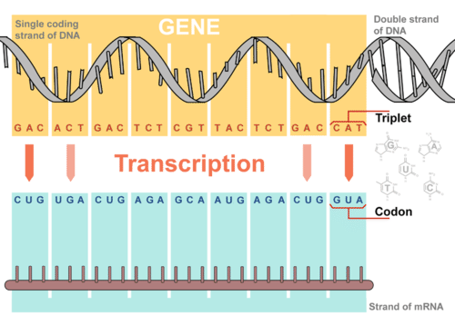
Overview of Transcription. Transcription uses the sequence of bases in a strand of DNA to make a complementary strand of mRNA. Triplets are groups of three successive nucleotide bases in DNA. Codons are complementary groups of bases in mRNA.

Steps of Transcription
Transcription takes place in three steps: initiation, elongation, and termination. The steps are illustrated in Figure below.
- Initiation is the beginning of transcription. It occurs when the enzyme RNA polymerase binds to a region of a gene called the promoter. This signals the DNA to unwind so the enzyme can “read” the bases in one of the DNA strands. The enzyme is ready to make a strand of mRNA with a complementary sequence of bases.
- Elongation is the addition of nucleotides to the mRNA strand.
- Termination is the ending of transcription. The mRNA strand is complete, and it detaches from DNA.
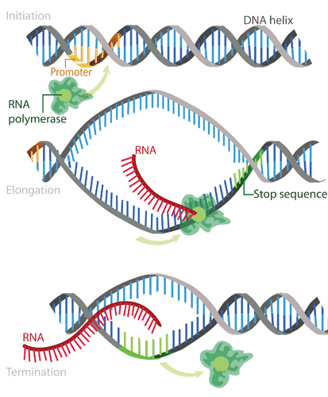
Steps of Transcription. Transcription occurs in the three steps - initiation, elongation, and termination - shown here.

Processing mRNA
In eukaryotes, the new mRNA is not yet ready for translation. It must go through more processing before it leaves the nucleus. This may include splicing, editing, and polyadenylation. These processes modify the mRNA in various ways. Such modifications allow a single gene to be used to make more than one protein.
- Splicing removes introns from mRNA (see Figure below). Introns are regions that do not code for proteins. The remaining mRNA consists only of regions that do code for proteins, which are called exons. You can watch a video showing splicing in more detail at this link: http://vcell.ndsu.edu/animations/mrnasplicing/movie-flash.htm. Ribonucleoproteins are nucleoproteins that contains RNA. Small nuclear ribonuclearproteins are involved in pre-mRNA splicing.
- Editing changes some of the nucleotides in mRNA. For example, the human protein called APOB, which helps transport lipids in the blood, has two different forms because of editing. One form is smaller than the other because editing adds a premature stop signal in mRNA.
- Polyadenylation adds a “tail” to the mRNA. The tail consists of a string of As (adenine bases). It signals the end of mRNA. It is also involved in exporting mRNA from the nucleus. In addition, the tail protects mRNA from enzymes that might break it down.
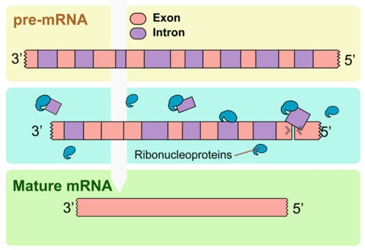
Splicing. Splicing removes introns from mRNA. UTR is an untranslated region of the mRNA.

The Genetic Code
How is the information in a gene encoded? The answer is the genetic code. The genetic code consists of the sequence of nitrogen bases—A, C, G, T (or U)—in a polynucleotide chain. The four bases make up the “letters” of the genetic code. The letters are combined in groups of three to form code “words,” called codons. Each codon stands for (encodes) one amino acid, unless it codes for a start or stop signal.
There are 20 common amino acids in proteins. There are 64 possible codons, more than enough to code for the 20 amino acids. The genetic code is shown in Figure below. To see how scientists cracked the genetic code, go to this link: http://www.dnalc.org/view/16494-Animation-22-DNA-words-are-three-letters-long-.html.
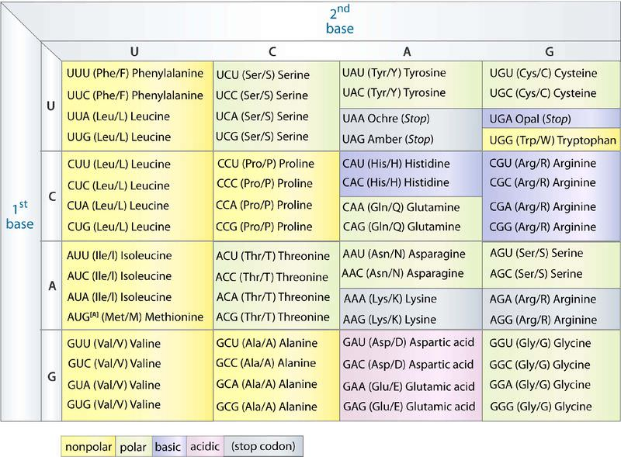
The Genetic Code. To find the amino acid for a particular codon, find the cell in the table for the first and second bases of the codon. Then, within that cell, find the codon with the correct third base. For example CUG codes for leucine, AAG codes for lysine, and GGG codes for glycine.

Reading the Genetic Code
As shown in Figure above, the codon AUG codes for the amino acid methionine. This codon is also the start codon that begins translation. The start codon establishes the reading frame of mRNA. The reading frame is the way the letters are divided into codons. After the AUG start codon, the next three letters are read as the second codon. The next three letters after that are read as the third codon, and so on. This is illustrated in Figure below. The mRNA molecule is read, codon by codon, until a stop codon is reached. UAG, UGA, and UAA are all stop codons. They do not code for any amino acids.
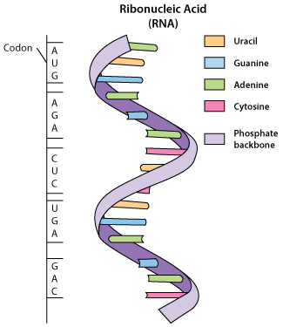
Reading the Genetic Code. The genetic code is read three bases at a time. Codons are the code words of the genetic code. Which amino acid does codon 2 in the drawing stand for?

Characteristics of the Genetic Code
The genetic code has a number of important characteristics.
- The genetic code is universal. All known living things have the same genetic code. This shows that all organisms share a common evolutionary history.
- The genetic code is unambiguous. Each codon codes for just one amino acid (or start or stop). What might happen if codons encoded more than one amino acid?
- The genetic code is redundant. Most amino acids are encoded by more than one codon. In Figure above, how many codons code for the amino acid threonine? What might be an advantage of having more than one codon for the same amino acid?

Translation
Translation is the second part of the central dogma of molecular biology: RNA → Protein. It is the process in which the genetic code in mRNA is read to make a protein. Figure below shows how this happens. After mRNA leaves the nucleus, it moves to a ribosome, which consists of rRNA and proteins. The ribosome reads the sequence of codons in mRNA. Molecules of tRNA bring amino acids to the ribosome in the correct sequence.
To understand the role of tRNA, you need to know more about its structure. Each tRNA molecule has an anticodon for the amino acid it carries. An anticodon is complementary to the codon for an amino acid. For example, the amino acid lysine has the codon AAG, so the anticodon is UUC. Therefore, lysine would be carried by a tRNA molecule with the anticodon UUC. Wherever the codon AAG appears in mRNA, a UUC anticodon of tRNA temporarily binds. While bound to mRNA, tRNA gives up its amino acid. Bonds form between the amino acids as they are brought one by one to the ribosome, forming a polypeptide chain. The chain of amino acids keeps growing until a stop codon is reached. To see how this happens, go the link below. http://www.youtube.com/watch?v=B6O6uRb1D38 (1:29)
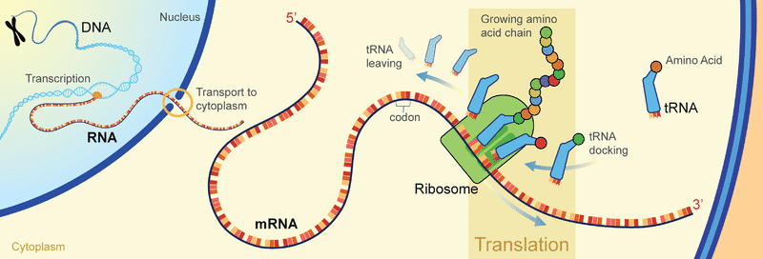
Translation. Translation of the codons in mRNA to a chain of amino acids occurs at a ribosome. Find the different types of RNA in the diagram. What are their roles in translation?
After a polypeptide chain is synthesized, it may undergo additional processes. For example, it may assume a folded shape due to interactions among its amino acids. It may also bind with other polypeptides or with different types of molecules, such as lipids or carbohydrates. Many proteins travel to the Golgi apparatus to be modified for the specific job they will do. You can see how this occurs by watching the animation at this link: http://vcell.ndsu.edu/animations/proteinmodification/movie-flash.htm.

Lesson Summary
- Transcription is the DNA → RNA part of the central dogma of molecular biology. It occurs in the nucleus. During transcription, a copy of mRNA is made that is complementary to a strand of DNA. In eukaryotes, mRNA may be modified before it leaves the nucleus.
- The genetic code consists of the sequence of bases in DNA or RNA. Groups of three bases form codons, and each codon stands for one amino acid (or start or stop). The codons are read in sequence following the start codon until a stop codon is reached. The genetic code is universal, unambiguous, and redundant.
- Translation is the RNA → protein part of the central dogma. It occurs at a ribosome. During translation, a protein is synthesized using the codons in mRNA as a guide. All three types of RNA play a role in translation.

Lesson Review Questions

Recall
1. Describe transcription.
2. How may mRNA be modified before it leaves the nucleus?
3. What is the genetic code? What are codons?
4. Outline the steps of translation.

Apply Concepts
5. Use the genetic code in Figure above to translate the following segment of RNA into a sequence of five amino acids:
GUC-GCG-CAU-AGC-AAG

Think Critically
6. The genetic code is universal, unambiguous, and redundant. Explain what this means and why it is important.
7. How are transcription and translation related to the central dogma of molecular biology?

Points to Consider
When DNA is replicated or transcribed, accidents can happen, leading to a change in the base sequence.
- What do you think could cause such accidents to occur?
- How might the changes affect the reading frame? How might the encoded protein be affected?

