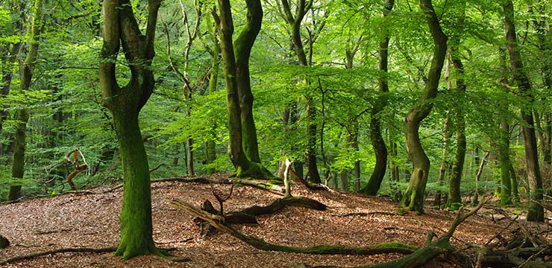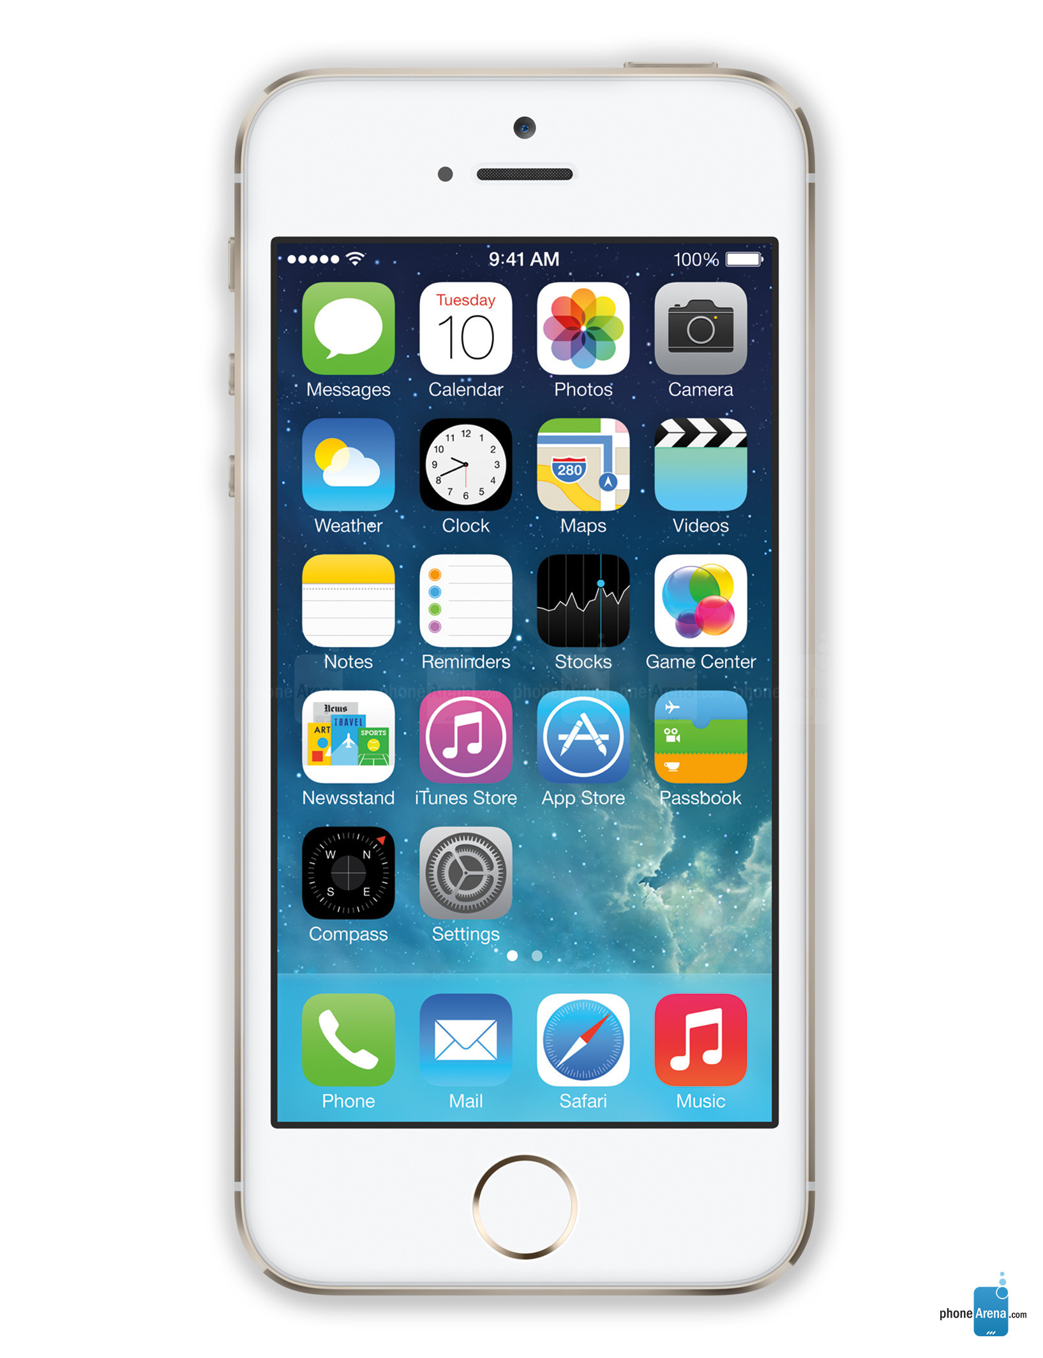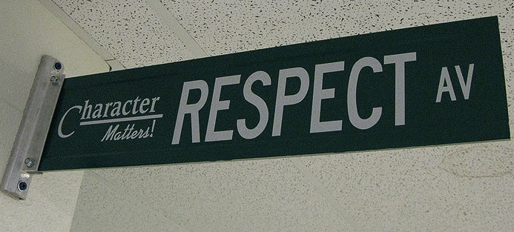 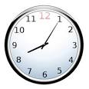

Hello and welcome to General Biology with Mrs. Jessica Bevins. In this course, we will study living things and how they live, grow, and work. We will also focus on careers that use the information we learn! We will cover the usual topics in a biology class; life, cells, ecosystems, body systems, plants, genetics, and biological evolution.

So what do you need for this class? There’s a list on the back. But most importantly, you need WORK ETHIC! With that characteristic, you WILL be successful in our class. With a lot of work ethic, respect, and willingness to collaborate with others, our class will be FUN this year. I’m looking forward to it and hope you are too.

In case you were wondering, this is my 8th year teaching at MSHS. I am married to Mr. Bevins (Math Dept.) and we have 2 wonderful boys; Aaron (8) and Daniel (3). I was an Environmental Field Biologist for 5 ½ years before becoming a teacher and LOVE the outdoors. I can’t wait to get to know you better!

I am here to help YOU! When you are confused, stuck, or just don’t know what to do, let me know! Write a note or raise your hand. I want to see YOU succeed!

## Our Class Website

Please be sure to visit our class website often! The URL is [www.bevinsbiology.weebly.com](http://www.bevinsbiology.weebly.com) . This website will be the go-to place to find course documents, assignments, and resources. Please check regularly to keep up-to-date with what’s going on in our classroom. It is VERY important that you have access to this website for success in class. What if you don’t have Internet access at home? We have access at school which you can use before/after school and/or during Advisory Time. There is also free Wi-Fi access at many local businesses and the public library. Plan your strategy now so that you don’t forget later.

#### If we aren’t using it as part of class, I shouldn’t see it.

#### Be kind & be respectful.

### Class Expectations

#### Follow directions the first time they are given.

#### Participate!

You won’t learn if you don’t participate.

All school rules also apply.

#### Be on time & be prepared.

General Biology

Mrs. Jessica Bevins – Room 204

**Planning**: 3rd Period

**Twitter:** @JBevinsBio

**Remind:** To receive updates and reminders via text, text “@bevinsbio” to 81010. To receive updates and reminders via app or email, visit <https://www.remind.com/join/mrsbevins> to sign up.

**Class Website:** [www.bevinsbiology.weebly.com](http://www.bevinsbiology.weebly.com) will be a resource you cannot do without this year.

## Classroom Connections

* Find the first letter of your last name and bring the item that corresponds
  + A-F – roll of paper towels
  + G-L – bottle of hand sanitizer
  + M-S – container of disinfectant wipes
  + T-Z – box of tissues

**YOU WILL NEED:**

* Writing utensils (pens or pencils)
* Paper/Notebook
* 2”- 3” 3-ring binder
* Dry erase marker for you to use in class (we will use these a lot!)
* A positive attitude, a sense of humor, & an open mind

**Entering Class:** Gather any necessary materials, quickly find your seat, and begin working on the warm-up posted on the board.

**Bathroom Usage:** Only 1 person will leave the classroom at a time. No passes will be given the 1st or last 10 minutes of each class period. No passes will be given during whole class/large group instruction.

**Food & Drink:** Food and drink are permitted in the classroom on non-lab days as long as you keep the room clean. If I have to clean up after any class, that class will NO LONGER be allowed food and drink in the classroom.

**Exiting Class:** The class will be dismissed by Mrs. Bevins. No one should quit work or put their belongings away before class is dismissed.

**Absences:** If you are absent, it is your responsibility to make up missed assignments. See the green crate at the front of the room labeled “General Biology” for handouts. After this, ask your group members what you missed. Finally, see Mrs. Bevins between classes for more information.

**Late Work:** For each day an assignment is late, 10% will be subtracted from that assignment’s score. After 10 days, assignments will no longer be accepted.

## Classroom Policies, Procedures, & Grading