Chapter 55 Reading Guide
Ecosystems and Restoration Ecology

Sections 1 and 2
- What is an ecosystem?
_________________________________________________________________________________________________
_________________________________________________________________________________________________

- Both energy and matter can be neither _____________________ or _____________________.

- What are the three groups of photosynthetic autotrophs?
_________________________________________________________________________________________________

- In the following image, identify each of the five trophic levels present

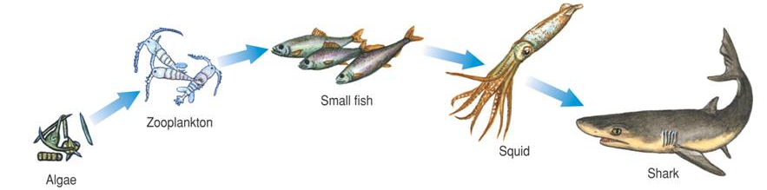
- What are detritivores? Name some examples.
_________________________________________________________________________________________________
_________________________________________________________________________________________________
_________________________________________________________________________________________________

- How are detritivores important in chemical cycling?
_________________________________________________________________________________________________
_________________________________________________________________________________________________
_________________________________________________________________________________________________
- Explain the difference between net primary productivity (NPP) and gross primary productivity (GPP).
_________________________________________________________________________________________________
_________________________________________________________________________________________________
_________________________________________________________________________________________________

- Describe the technique used to measure net primary productivity in an aquatic environment.
_________________________________________________________________________________________________
_________________________________________________________________________________________________
_________________________________________________________________________________________________

- What is a limiting nutrient?
_________________________________________________________________________________________________
_________________________________________________________________________________________________

- Name three possible limiting nutrients in aquatic ecosystems?
_________________________________________________________________________________________________

- What is eutrophication? How is it caused?
_________________________________________________________________________________________________
_________________________________________________________________________________________________
_________________________________________________________________________________________________

Section 3
- Define secondary production.
_________________________________________________________________________________________________
_________________________________________________________________________________________________

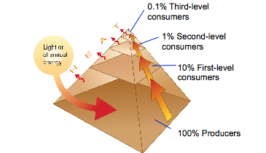
- If 50,000 kilocalories of energy are available in the producer level of this energy pyramid, how many calories are available to the tertiary consumers?

_________________________________________________________

- Why do people who have limited diets in overpopulated parts of the world eat low on the food chain? What is the advantage?
_________________________________________________________________________________________________
_________________________________________________________________________________________________

Section 4
(For questions 15-18, use key terms from the diagrams on page 1228-1229)
- Name four ways/processes that cycle water through the biosphere?
_________________________________________________________________________________________________
_________________________________________________________________________________________________

- Name four ways/processes that cycle carbon through the biosphere?
_________________________________________________________________________________________________
_________________________________________________________________________________________________

- Name four ways/processes that cycle phosphorous through the biosphere?
_________________________________________________________________________________________________
_________________________________________________________________________________________________

- Name four ways/processes that cycle nitrogen through the biosphere.
_________________________________________________________________________________________________
_________________________________________________________________________________________________

- Write the equations for photosynthesis and cellular respiration below.

- Define the term transpiration.
_________________________________________________________________________________________________
_________________________________________________________________________________________________

- Define nitrogen fixation.
_________________________________________________________________________________________________
_________________________________________________________________________________________________

- Define denitrification.
_________________________________________________________________________________________________
_________________________________________________________________________________________________

Section 5
- Explain bioremediation.
_________________________________________________________________________________________________
_________________________________________________________________________________________________

- Describe the process of biological augmentation.
_________________________________________________________________________________________________
_________________________________________________________________________________________________
_________________________________________________________________________________________________

