Chapter 4 Reading Guide
-Carbon and the Molecular Diversity of Life-

Sections 1 and 2
- What does organic chemistry specifically study?
_________________________________________________________________________________________________

- Since we will be studying Carbon, it is essential that you know the answers to these questions.
  - How many valence electrons does carbon have? _________
  - How many bonds can carbon form? _________
  - What type of bonds does it form with other elements? __________

- What is a hydrocarbon? Are hydrocarbons hydrophilic or hydrophobic?
_________________________________________________________________________________________________
_________________________________________________________________________________________________
 | Definition | Example
Isotope

Isomer

- In Chapter 2 you learned what an isotope is. Since often students confuse this word with an isomer, define each term here and give an example.

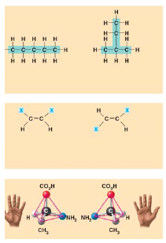
- Use this figure to identify the three types of isomers. For each type, give a key character and an example.

- Give one example of enantiomers that vary in their pharmacological effect.
____________________________________________________________
____________________________________________________________
____________________________________________________________

Section 3
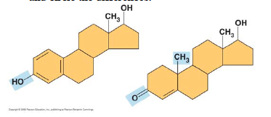
- Here is an idea that will recur throughout your study of the function of molecules: change the structure, change the function. You see this in enantiomers, you will see it in proteins and enzymes, and now we are going to look at testosterone and estradiol. Notice how similar these two molecules are, and yet you know what a vastly different effect each has. Label each molecule in the sketch below and circle the differences.

- Define functional group.
_________________________________________________________________________________________________
_________________________________________________________________________________________________
- Here are seven functional groups. Complete the following chart.
 | Hydroxyl | Carbonyl | Carboxyl | Sulfhydryl | Amino | Phosphate | Methyl
Structure

Example

Functional
Properties

- You will need to master the chart and the information in it. For each prompt, which of the above functional groups is described.
  - –NH₂
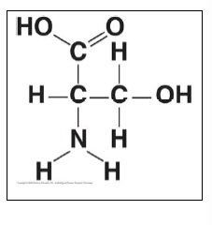
  - can form cross-links that stabilize protein structures
  - key component of ATP
  - can affect gene expression
  - CH₃
  - Is always polar
  - Determines the two groups of sugars
  - Has acidic properties
  - –COOH
  - acts as a base
  - circle and identify three functional groups in the molecule shown above.

