Chapter 2: The Chemical Context of Life
-AP Biology Guided Reading-

Sections 1 and 2

- Define and given an example of the following terms:
  - Matter ________________________________________________________________________________
_________________________________________________________________________________________
  - Element ______________________________________________________________________________
_________________________________________________________________________________________
  - Compound ___________________________________________________________________________
_________________________________________________________________________________________

- What four elements make up 96% of all living matter?
_________________________________________________________________________________________________

- Explain the difference between an essential element and a trace element.
_________________________________________________________________________________________________
_________________________________________________________________________________________________
_________________________________________________________________________________________________

- What is the atomic number of Carbon? The atomic mass?
_________________________________________________________________________________________________

- Sketch a model of Carbon, showing the electrons, protons, neutrons, and atomic nucleus.

- Provide the charges of each of the subatomic particles. Where is each particle located?
  - Proton _______________________________________________________________________________
  - Neutron ______________________________________________________________________________
  - Electron ______________________________________________________________________________

- Define the following terms:
  - Atomic mass _________________________________________________________________________
_________________________________________________________________________________________
  - Isotope _______________________________________________________________________________
_________________________________________________________________________________________

- Give a basic overview of how radioactive isotopes work.
_________________________________________________________________________________________________
_________________________________________________________________________________________________
_________________________________________________________________________________________________

- What determines the chemical properties/behavior of an atom?
_________________________________________________________________________________________________

- Here is an electron distribution diagram for sodium:
  - How many valence electrons does it have? Circle them.
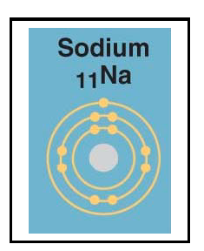
  - How many protons does it have?
  - Assuming it is a neutral molecule, how many electrons does it have?
  - Given that the mass number is 23, how many neutrons does it have?

Sections 3 and 4

- Define molecule: _____________________________________________________________________________
_________________________________________________________________________________________________

- What does the term electronegativity mean?
_________________________________________________________________________________________________
_________________________________________________________________________________________________

- Explain the difference between a nonpolar covalent bond and a polar covalent bond.
_________________________________________________________________________________________________
_________________________________________________________________________________________________
_________________________________________________________________________________________________

- Does water form a nonpolar covalent bond, or a polar covalent bond? Explain why.
_________________________________________________________________________________________________
_________________________________________________________________________________________________

- Draw a diagram of a water molecule, labeling the regions that are more positive or more negative.

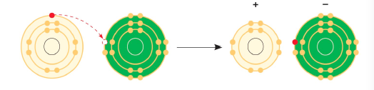
- Another type of bond is shown here. State what type of bond this is, what two elements are involved, and explain what is happening in the diagram.

- Explain the terms anion and cation, and how they are formed. In the previous example, which element is the anion, and which is the cation?
__________________________________________________________________________________________________________________________________________________________________________________________________
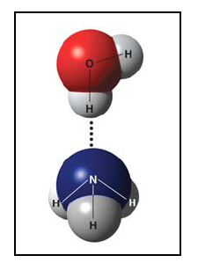
_________________________________________________________________________________________________

- What is a hydrogen bond? Indicate where the hydrogen bond occurs in this figure.

- Describe van der Waals interactions.
_________________________________________________________________________________________________
_________________________________________________________________________________________________

- Place the following in order from weakest to strongest: van der Waals, covalent bonds, ionic bonds, hydrogen bonds.
_________________________________________________________________________________________________

- Why is molecular shape so important in cells?
__________________________________________________________________________________________________________________________________________________________________________________________________

- Write the chemical equation for photosynthesis, labeling the reactants and the products.

- Explain dynamic chemical equilibrium.
__________________________________________________________________________________________________________________________________________________________________________________________________
_________________________________________________________________________________________________

