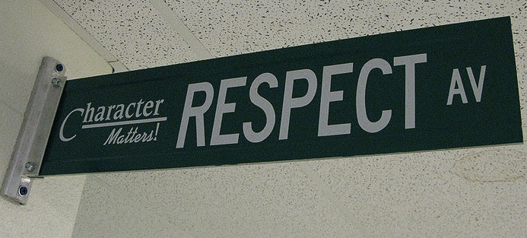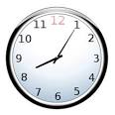

**Remind**: send a text to 81010 with the message “@apbiobevin” for class updates and important reminders OR follow this link <https://www.remind.com/join/apbiobevin>

**Room #:** 204

**Planning**: 3rd Period

**Instructor Contact** Mrs. Jessica Bevins

**Class Website**: [www.bevinsbiology.weebly.com](http://www.bevinsbiology.weebly.com) This website will be the go-to place to find course documents, assignments, and resources.

**Twitter**: @JBevinsBio



## Classroom Connections

AP Biology is designed to be the equivalent of a college biology course usually taken by biology majors. The requirements of this class are demanding, and **you will be expected to complete college level work**. You will be required to spend a considerable amount of time working outside of the classroom. Reading and taking notes from your text is mandatory! Success in this course will **not occur** unless you are dedicated to complete each assignment to your best ability.

# Course Description

#### Be kind & be respectful.

### Class Expectations

#### Follow directions the first time they are given.

#### If it’s not being used in class, leave it AWAY.

All school rules also apply.

#### Participate!

#### Be on time & be prepared.

AP Biology

**YOU WILL NEED CONTINUED:**

* Find the first letter of your last name and bring the item that corresponds
  + A-F – roll of paper towels
  + G-L – bottle of hand sanitizer
  + M-S – container of disinfectant wipes
  + T-Z – box of tissues

**YOU WILL NEED:**

* Writing utensils (pens or pencils)
* Paper
* 2”– 3” 3-ring Binder
* A positive attitude, a sense of humor, & an open mind
* I also recommend purchasing an AP Review book. Not only will this help you prepare for the AP exam, it will be a valuable tool for studying and preparing for unit tests. Make sure it is a review book for the new curriculum (2013 or newer).

**After 10 school days, the assignment will not be accepted.**

**Extra Help:** You are not in this alone. Should you need additional help, I am available before and after school most days upon request. I will host tutoring session regularly beginning in September/October.

**Extra Credit**: Extra credit will be available once each term, but can only be completed by students who have turned in ALL other work. Any missing work makes you **ineligible** to complete extra credit assignments.

**Entering Class:** Gather any necessary materials, quickly find your seat, and begin working on the warm-up posted on the board.

**Hall Passes:** Only 1 person will be permitted to leave the room at a time. Do not ask to leave during whole group instruction! No one leaves class the first or last 10 minutes of any class.

**Food:** Food and drink are permitted in our classroom as long as you clean up after yourself. No food/drink on lab days!

**Exiting Class:** In our class, we will work until the bell or Mrs. Bevins releases you.

**Absences:** If you are absent, it is your responsibility to make up missed assignments. See the green crate at the front of the room labeled “AP Biology” for handouts. THEN, ask your group members about class. FINALLY, ask me between classes. In accordance with school policy, students who are absent will have the number of days they were absent, plus one additional day to complete their make-up work. (Ex: if you miss Monday, you have Tuesday and Wednesday to get caught up, and your work is due on Thursday). If make-up work is not completed in the allotted time frame, it will be treated as a late assignment.

**Late Work Policy:** In this class, the late work policy is that for every day the assignment is late, 10% will be taken from the score achieved.

## Classroom Policies & Procedures